**CSC 250 – Program Design Document**

**Structure Chart**

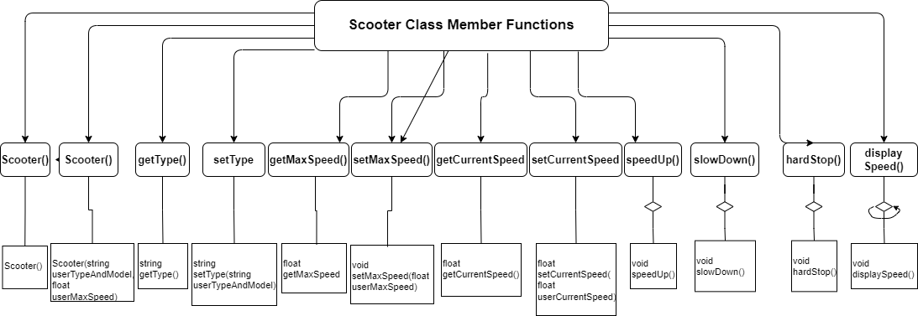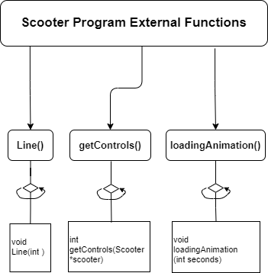

**Function Design (give the prototype and a short description for each function)**

**Public Functions**

1. **Scooter()** - Default constructor. Initializes the name, max speed, and current speed to default values.
   1. Parameters: None
   2. Returns: None
2. **Scooter(string name, float maxSpeed)** - Second constructor. Initializes the name and max speed to the values specified by the user, and the current speed to 0.
   1. Scooter(string userTypeAndModel, float userMaxSpeed)
   2. Parameters:
      1. name - The name of the scooter. A string.
      2. maxSpeed - The maximum speed of the scooter. A float.
   3. Returns: None
3. **string getType(): An accessor function to retrieve the type and model of the scooter as a string.**
   1. string getType()
   2. Parameters: None
   3. Returns: A string representing the ype and model of the scooter.
4. **setType(string userTypeAndModel):** A mutator function to modify the type and model of the scooter.
   1. void setType(string userTypeAndModel)
   2. Parameters:
      1. name - The new name of the scooter. A string.
   3. Returns: None
5. **getMaxSpeed()** - Accessor function for the max_speed member variable.
   1. float getMaxSpeed()
   2. Parameters: None
   3. Returns: A float representing the maximum speed of the scooter.
6. **setMaxSpeed(float userMaxSpeed)** - Mutator function for the max_speed member variable.
   1. void setMaxSpeed(float userMaxSpeed)
   2. Parameters:
      1. maxSpeed - The new maximum speed of the scooter. A float.
   3. Returns: None
7. **getCurrentSpeed()** - Accessor function for the current_speed member variable.
   1. float getCurrentSpeed()
   2. Parameters: None
   3. Returns: A float representing the current speed of the scooter.
8. **setCurrentSpeed(float userCurrentSpeed)** - Mutator function for the userCurrentSpeed member variable to modify the scooter’s current speed.
   1. void setCurrentSpeed(float userCurrentSpeed)
   2. Parameters:
      1. userCurrentSpeed - The new current speed of the scooter. A float.
   3. Returns: None
9. **speedUp()** - Function to increase the speed of the scooter by 2 mph, up to the maximum speed.
   1. void speedUp()
   2. Parameters: None
   3. Returns: None
10. **slowDown()** - Function to decrease the speed of the scooter by 3 mph, down to 0.
    1. void slowDown()
    2. Parameters: None
    3. Returns: None
11. **void displaySpeed():** A function to display the current speed of the scooter like a digital speedometer.
12. **void hardStop():** A function to set the current speed of the scooter to 0.

External Functions

* **Line(int num)**
  + Description: Prints a line of dashes with a specified length.
  + Function prototype: void Line(int num);
  + Parameters:
    - num - The number of dashes to print. An integer.
  + Returns: None.
* **loadingAnimation(int seconds)**
  + Description: Displays a loading animation for a specified number of seconds.
  + Function prototype: void loadingAnimation(int seconds);
  + Parameters:
    - seconds - The number of seconds to display the animation for. An integer.
  + Returns: None.
* **configureScooter(Scooter *scooter)**
  + Description: Prompts the user for the brand and model of the scooter and sets them to the object's properties.
  + Function prototype: void configureScooter (Scooter *scooter);
  + Parameters:
    - scooter - A pointer to the Scooter object to configure.
  + Returns: None.
* **getControls(Scooter *scooter)**
  + Description: Prompts the user for input and calls the appropriate function based on user input.
  + Function prototype: int getControls(Scooter *scooter);
  + Parameters:
    - scooter - A pointer to the Scooter object to control.
  + Returns: The user's choice as an integer.
* **main()**
  + Description: The main function. Calls the configureScooter function to configure a Scooter object, then repeatedly calls the getControls function to control the scooter until the user chooses to exit.
  + Function prototype: None.
  + Parameters: None.
  + Returns: None.

**Time Estimate**

|  |  |  |
| --- | --- | --- |
|  | **Estimated Time** | **Actual Time** |
| Program Design |  |  |
| (list each function name and the time required to code each) |  |  |
|  |  |  |
|  |  |  |
|  |  |  |
| Program Test |  |  |
| **Total Time** |  |  |